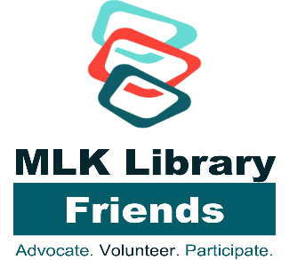

Please donate your used books in very good to excellent condition to the MLK Library Friends.
We especially need the following types of books and media:

Fiction * History * Children’s Picture Books * Cookbooks * Political Books *Art and Architecture * Biography * Science Fiction * Science*
Coffee Table Books * DVD movies * CDs

Please bring your books to the Friends Room on the A level of Martin Luther King, Jr. Memorial Library at scheduled times. (Ninth and G Streets, NW) A volunteer will review your books before accepting them and giving you a receipt. Donation limit: 2 bags of books

Important: We are sorry we cannot accept textbooks, magazines and journals, VHS tapes, law books, reference books including encyclopedia and dictionaries, travel books over three years old, or dirty, dusty or water damaged books. Nor can we accept books with missing dust jackets.

Please donate books only to a Friends volunteer. Do not leave books unattended anywhere in the Library.
________________________
The sale of your donated used books will be used to support programs at the Martin Luther King, Jr. Memorial Library and other DC Public Library programs.

